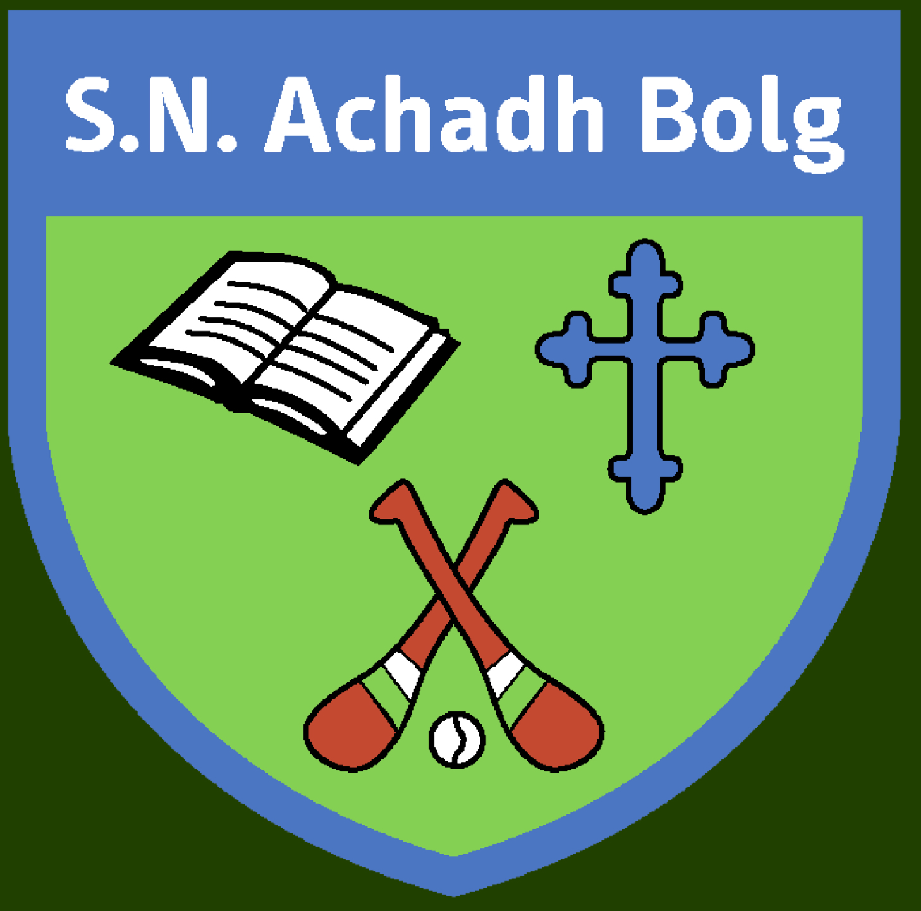 Aghabullogue National School

6th Class Booklist 2021/22
€45 payable on-line from September, via Aladdin App will cover the costs for the Book rental as well as Printing/Photocopying/Art supplies and Aladdin Connect.
The highlighted items are supplied by the schools’ Book Rental Scheme. All other items are available to purchase on schoolbooks.ie or in any good retailers.

ENGLISH :
Over the Moon Reader 6th
Over the Moon Skills Book 6th
My Read At Home Book 6
Jolly Grammar 6
Just Handwriting 6th
English Dictionary

GAEILGE:
Abair Liom H
Léigh sa Bhaile F

MATHS:
Planet Maths 6th Class – Textbook
Tables Champion 6
Work It Out 6

SESE:
Small World Geog+Science 6 (13.20)
Small World History 6 (13.20)
Just Maps 5th class
Atlas (Should have from 5th class)

Religion:
Grow and Love

Other:
- Homework diary (3.00)
- Art Scrap Book
Stationery
A4 – Hard back copies x2
8 x 120 page covered
2 x 120 pages maths copies (C3) with plastic covers
Child sized scissors.
Red biro x 2, blue biro x 2, pencils (hb) x 2, 1 ruler (30cm), topper, eraser, high lighter marker.
Colouring pencils/twistables, 2 x pritt stick (40g) with child’s name on it, maths set including compass & protractor (should have already from 5th class)

