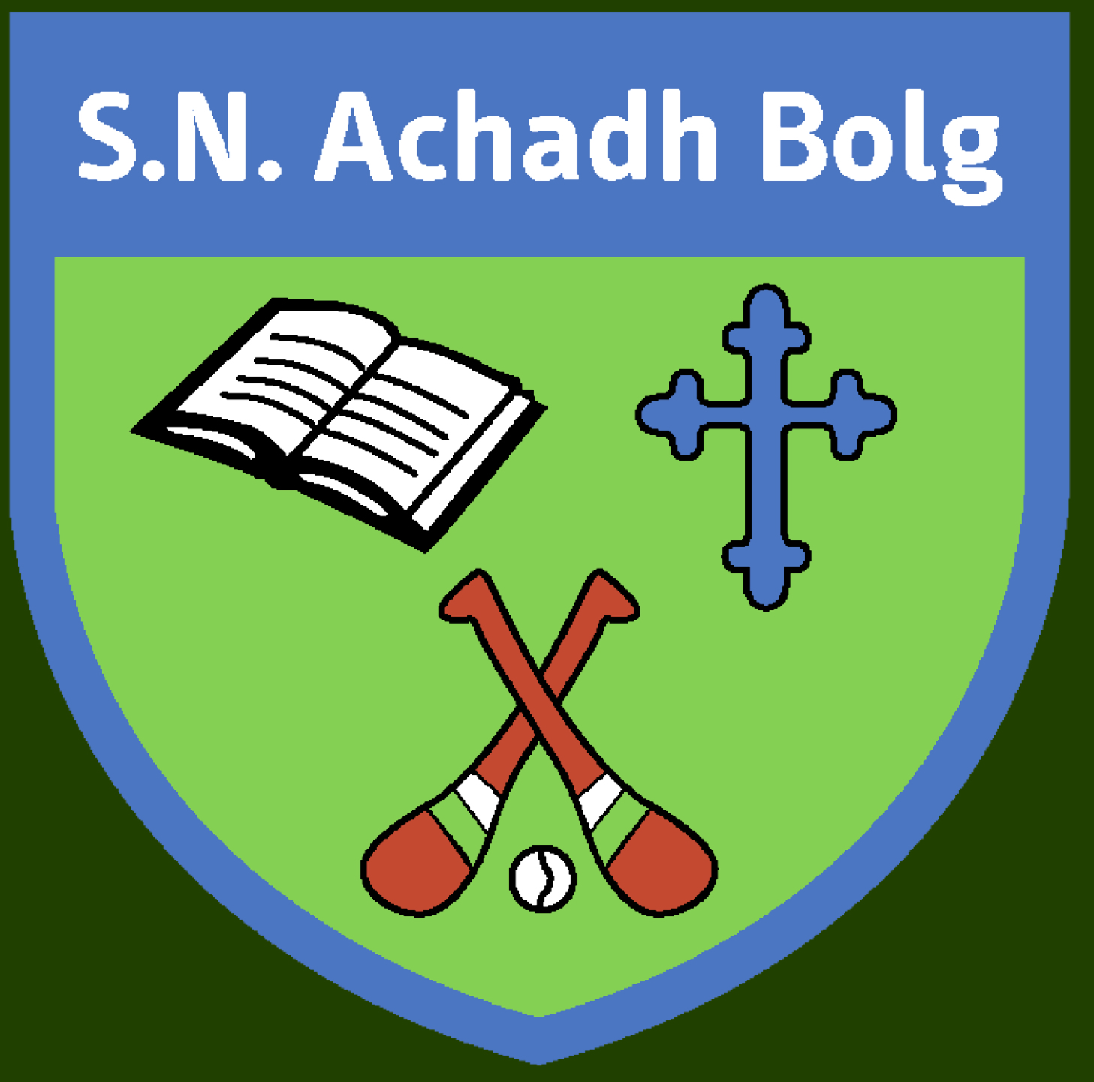 Aghabullogue National School

Senior Infant Booklist 2021/22
A cost of €35 will cover the cost of rental books, photocopying/art supplies, Aladdin Connect and all of the copies/folders detailed below.

Rental Books- Provided by the school
Over the Moon Readers Fiction: 9 Books
Over the Moon Readers Non-Fiction: 9 Books

Copies & Folders-Provided by the school.
X2 Project Copies 15a (Ormond, Purple cover) (Free writing, News, spare) (1.35c)
X2 Plain Day Copies (40pg, Ormond, Yellow Cover) (Cóipleabhar Gaeilge, Drawing copy) (0.90c)
X2 Learn to Write Copies (15mm Ruling - 40 Page, Ormond, Purple cover, J09) (Literacy
Stations, Phonics Homework) (0.90c)
X1 Scrapbook (24pg, A4, Visual Arts) (1.25c)

Note: The following books can be purchased on the schoolbooks.ie website or in any good retailers.
English
Over the Moon Senior Infants Skills Book
Mrs. Murphys Senior Infant Copies

Maths
Planet Maths Senior Infants

Religion
Grow in Love Junior Infants

Gaeilge
-Bua na Cainte B: Naíonáin Shinsearacha

SESE
Explore with Me Senior Infants

