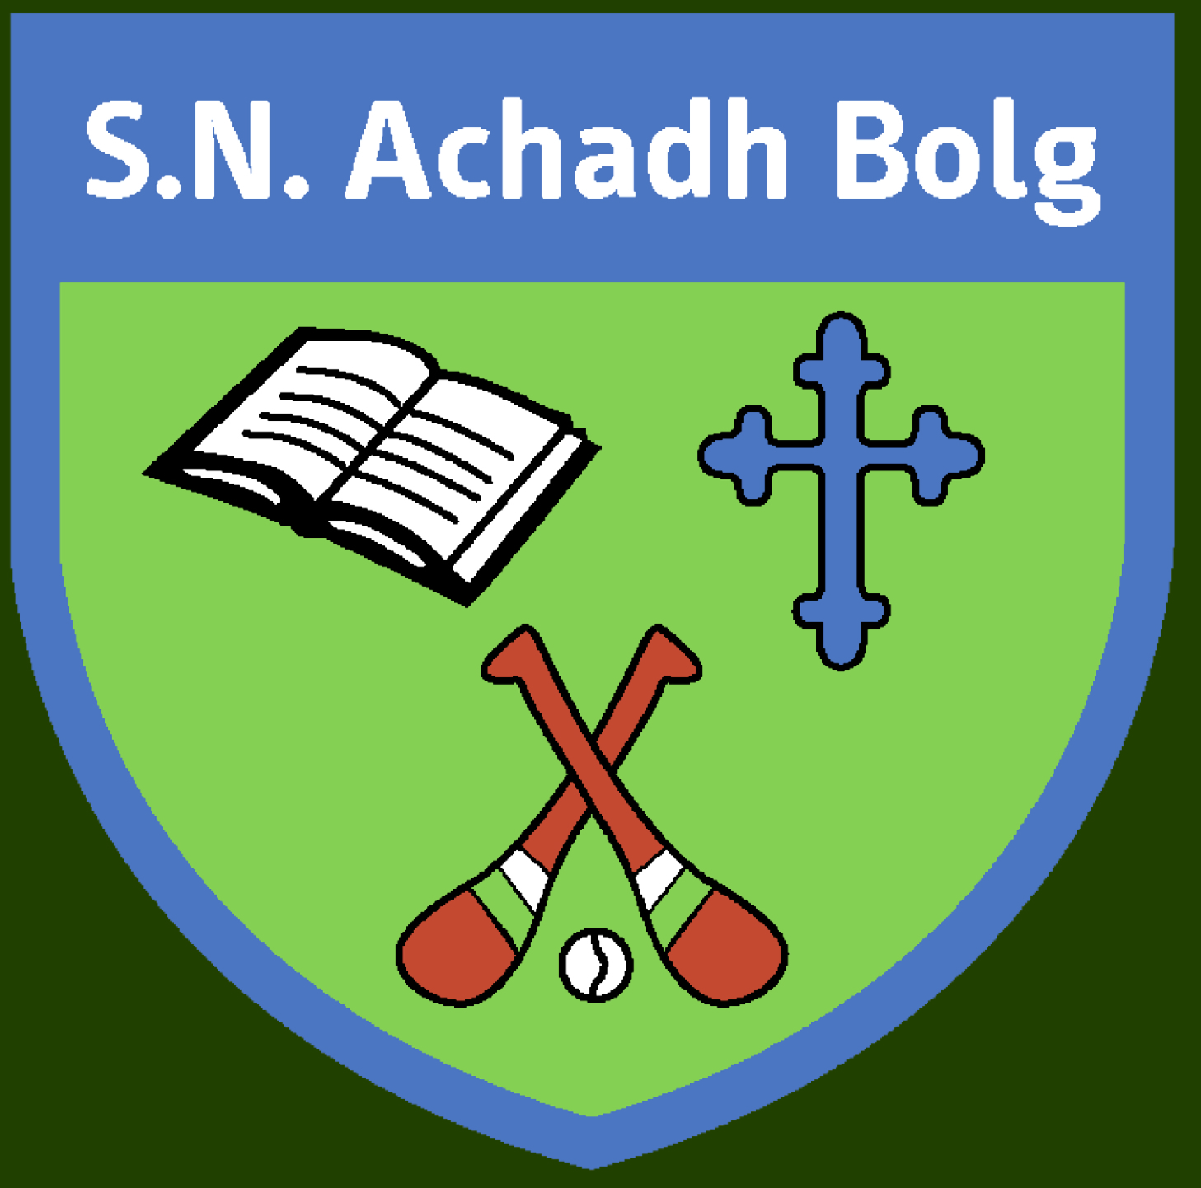 Aghabullogue National School

1st Class Booklist 2021/22
€45 payable on-line from September, via Aladdin App will cover the costs of the Book Rental scheme. Printing/Photocopying/Art/Aladdin connect. The items below which are highlighted are covered by the book rental scheme. All other items are available to purchase on schoolbooks.ie or from any good retailer.
*If your Child Has an IRISH EXEMPTION they still pay the full amount as they will receive extra books/Software to support their learning instead of the Irish Books*

ENGLISH
Readers : Over the Moon Reader 1st Class
Workbooks : Over the Moon Skills Book 1st Class
Handwriting Made Easy – Looped Style First Class
Jolly Phonics 1st Class Grammar 2 Pupil Book

GAEILGE
Bua na Cainte 2

MATHS
Work it Out 1st Class
Tables Champion 1
Planet Maths 1st Class Text Book

SESE
Small World

RELIGION
Grow In Love

Stationery
Homework diary
Art Scrap Book

5x120 page copies
2x Maths copies
2x handwriting copies. Type B2 (must have the blue and red lines)
1x A4 copy (soft cover)
A4 plastic display folder
Zipped A4 Mesh Storage Wallet

